The Neo Geo Pocket was created by SNK(Japan) at 1998 and was followed by the Neo Geo Pocket Color soon after.
NeoGeo Pocket Specs:  - 16 bit TOSHIBA TLCS-900H high performance core CPU  - 32 bit/16 bit register bank cofiguration @ 6.144 MHz  - Virtual screen 256×256 - 16 palettes/plane, 64 sprites/frame  - Z80 8 bit cpu sound  - 12 bit DAC & 6 psg tone simultaneous output  - I/O serial SIO 1 channel 19200 bit/s |  | NeoGeo Pocket Color Specs:  - CPUs: Toshiba TLCS900H core (16-bit), 6.144 MHz, Z80 at 3.072 MHz for sound.  - RAM: 12 k for 900H, 4k for Z80  - ROM: 64 kbit boot ROM  - Interfaces: SIO 1 channel 19200 bit/s, 5-pin serial port  - Resolution: 160x152  - Colors: 16 palettes per plane, 48 palettes. 146 colors on screen out of 4096.** NEO GEO POCKET color mode, 20 colors out of 4096.  - Sprites: 64 sprites per frame, 4 colors per sprite*.  - Scrolling: 2 scrolling planes, 8x8 character tiles, 4 colors each*.  - Sound: PSG 6 tone simultaneous output. Stereo sound.  - Cartridges: Maximum 2 MB (16 Mbit) with 4-16 Mbit flash memory.  - Batteries: 40 hours on 2 AA batteries. Lithium battery backs up memory and clock.
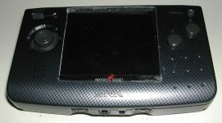
NeoGeo Pocket
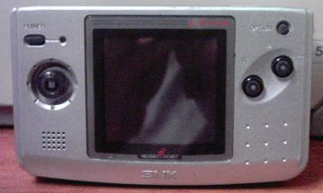
NeoGeo Pocket Color

